Student’s Name
Institution Affiliation
Name of the Professor
Date of Submission

Introduction.
Bradbury Thompson and Kurt Schwitters are two different designers and topographers with different styles and some similarities in their artwork. Both worked in different movements but with the same career; Thompson worked at New York School while Schwitters was in the Dada movement. According to Varish (2019), the innovative change by these two designers spread with their layouts, although they had different techniques of presenting their work which was unusual and exciting for viewers. Their graphic designs are so attractive, thus why I chose them. Art Nouveau is an international decorative style that uses organic, plantlike lines and Signifies bursting of energy or a flow of elegance, thus making the two artists and their movement relate with this artwork. We will discuss techniques and types of posters produced by these movements, time, artists, and improvements in their attractiveness.
Bradbury Thompson is an American designer born in the year 1911 in Topeka, Kansas. He got interested in graphic work before even people understood what design as a profession was. Thompson spent most of his time in school at the drug store, poring over well-done fashion magazines like Vogue and Vanity Fair. He graduated from Washburn College with economics, but he was involved in design throughout his high school and college career. He considered himself; dabbling in illustration, drafting, layout, and typography to understand method (Thompson & Helfand 2018). Thus, Thompson was known for his works in blending typography and images, designing magazine layouts, and becoming one of the most influential art directors in the twentieth century. He had won many awards in graphic work throughout his career as he worked in different organizations like Capper publication and later moved to New York and became the art director of Rogers-Kellog-Stillson printing firm before joining Mademoiselle Magazine as a director. During his career, he designed more issues but majored more in Magazine layout.
Kurt Schwitters was a German artist born in 1887 who experimented with many techniques in his careers, such as collage, sculpture, typography, poetry sound, painting, and graphic design. He was involved in the Dada design movement after he left to serve in the military in 1917. He studied at Kunstakademie in Dresden, where he began experimenting with cubist and Expressionist styles after he left the military, but he created styles of his own. In his time after World War 1 as a draftsman influenced his later work and inspired him to depict machines as metaphors of human activity. He innovated one of his famous works called Merz, and he quoted, "In the war, things were in terrible turmoil. What I had learned at the academy was of no use to me and the useful new ideas were still unready.... Everything had broken down and new things had to be made out of the fragments; and this is Merz. It was like a revolution within me, not as it was, but as it should have been" (Rasula 2020). This made him so famous for his innovation and creativity in his artwork.
Kurt Schwitters and Bradbury Thompson's works were similar because they both design the layouts for a magazine cover and inside spread. Their main image on the cover always captures the attention at first glance because of its compelling image shown with easiness and cleanliness. As for the inside spread, the elements complement each other very well. Both designers use the images and body copy to create a beautiful and dynamic look full of energy and excitement. They also used colour to decollate their work for the attractiveness to their viewers though the colors' were different for different purposes. Also, on the similarities, their artwork was out of experiments made after world war one and world war two.
Despite their similarities, Thompson looks to be more innovative than Schwitters out of his artwork. He had worked in different movements to produce many projects, such as the college Bible, which was one of his best artworks after designing a wartime periodical used against the enemies. His idea in art design made him more famous as he worked in various movements like Westvaco Inspirations, Mademoiselle Magazine, and later to New York School as a teacher and director where he taught people the importance of innovation in art design.
Another exciting project Thompson took on that was different than his usual book, and magazine design career was designing over a hundred stamps for the U.S. Postal Service. Throughout his career, Thompson created over thirty-five Magazine layouts for different companies. By the end of his career, he was recognized by nearly every major American design organization, teaching job of topographic and role of topographic in design and winning awards such as the AIGA gold medal in 1975 and Art Directors Hall of Fame in 1977. He died in 1995 as one of the most influential graphic designers of the 1900s.
On the other hand, Schwitters began experimenting with Cubist and Expressionist styles but soon created a style all his own. His best-known design was periodical Merz, a revolutionary venture—covering a new topic for each issue and featured artist profiles, children's stories, and poetry. In his commercial career in graphic, he worked on advertising and layout design. His art design work was less than Thompson's, but he also had unique techniques in graphic work where he demonstrated the early days of our current industry. Schwitters marked the turning from art and craft to solid, where he used to collect the waste product and design valuable something out of i Varish (2019). This has progressed to a more formalized, grid-loving design aesthetic during the new topography movement. Thus this style made his work more unique from others which involved experiment and innovation.
Conclusion.
Schwitters and Thompson's styles of designing a magazine layout brought a lot of impact in the graphic art design. Their style in art also applicable in our industries even today. I agree with their idea of innovation and experimentation in art design which has made their work more famous here in the U.S. The modern art styles in Art Nouveau are some of the ideas used by the two designers who have made the topographic and art design work more attractive to people as they still apply their ideas.

Images
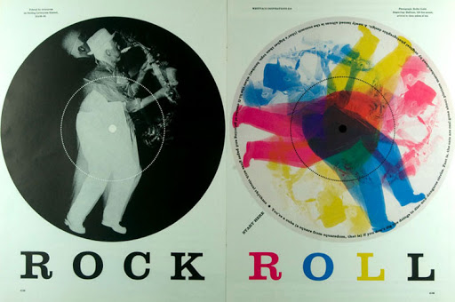
Bradbury Thompson
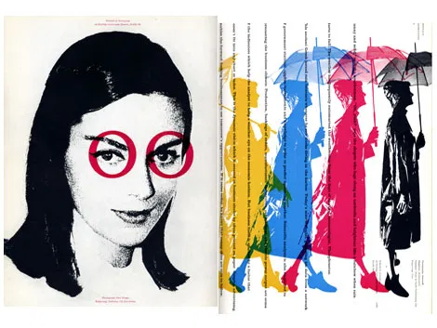
Bradbury Thompson Art work
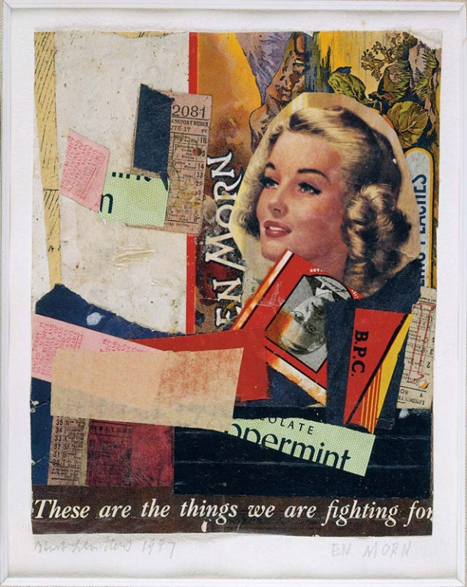
Kurt Schwitters
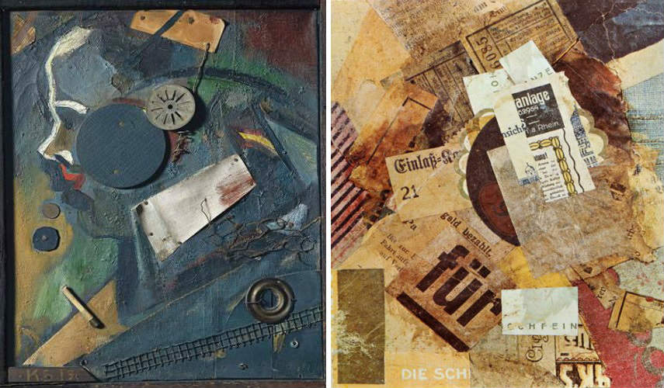
Kurt Schwitters widewalls

References.
Currier, B. (2019). The Process of Graphic Design as Illustrated Through the Project Bread+ Milk+ Eggs. Lulu. com.
Lewin, M. F. (2019). Artful Bodymind: Enlivening transformative research methodologies
McVarish, E. (2019). HISTORY FROM ATO Z. Teaching Graphic Design History.
Rasula, J. (2020). Acrobatic Modernism from the Avant-garde to Prehistory. Oxford University Press, USA.
Thompson, B., & Helfand, J. (2018). The art of graphic design. Yale University Press.

